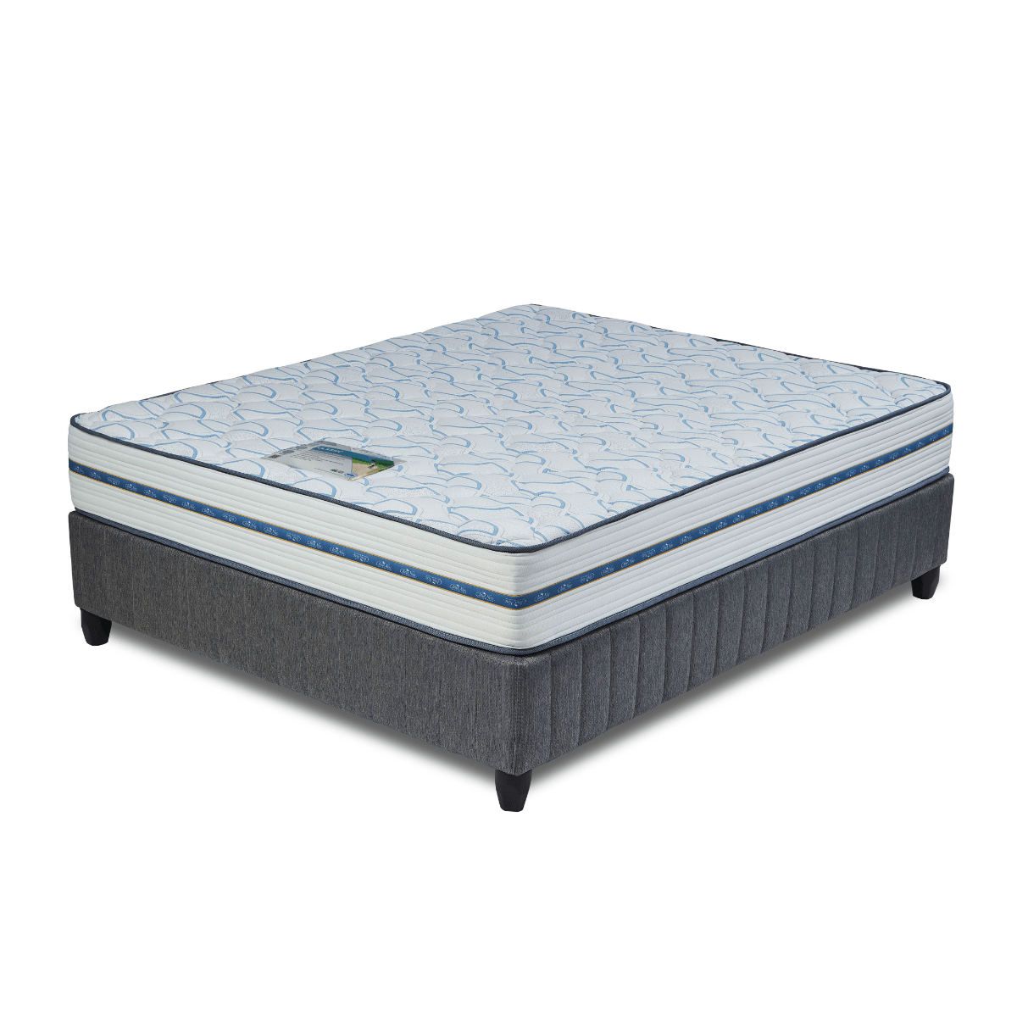


Model : Classic Bed Set
Supplier/Manufacturer : Cloud Nine
Range : Premium
Prices – Bed Set :
- Single Bed Set – R7539
- Three Quarter Bed Set – R8639
- Double Bed Set – R10529
- Queen Bed Set – R11459
- King Bed Set – R14519
Prices – Mattress Only :
- Single Mattress Only – R5889
- Three Quarter Mattress Only – R6809
- Double Mattress Only – R8509
- Queen Mattress Only – R9379
- King Mattress Only – R11209
Prices - Extra Length Bed Set :
- Single Extra Length Bed Set – R8149
- Three Quarter Extra Length Bed Set – R9329
- Double Extra Length Bed Set – R11379
- Queen Extra Length Bed Set – R12379
- King Extra Length Bed Set – R15679
Prices - Extra Length Mattress Only :
- Single Extra Length Mattress Only – R6359
- Three Quarter Extra Length Mattress Only – R7359
- Double Extra Length Mattress Only – R9189
- Queen Extra Length Mattress Only – R10129
- King Extra Length Mattress Only – R12109

*Please use this link for guideline for creating the page* - https://www.bedsonline.co.za/product/cloud-nine-classic-queen/
Cloud Nine Link - https://cloudnine.co.za/beds/premium/classic/

